**WEB TECHNOLOGY MINI-PROJECT**

**Newsplate**

**PROJECT BY**

       Bhavesh Patel     (39)

       Piyush Saravagi   (42)

       Suyash Thakare   (54)

 (C Batch T.E. COMPUTERS)

**Newsplate**

1. **Problem Definition**

**Abstract:**

The website will show the users various news based on their preferences. The preference can be set by registered users. The news would be categorized into categories including, but not limited to, technology, business, entertainment and sports

**Features:**

* Get personalized news
* Intuitive user interface
* Change your preference anytime
* Get daily notification (email) on news you may have missed

**Flow of the website:**

When the user visits the site, he/she will be presented with the current news on the home page of the website. User will have the option of registering on the website which will allow users to get personalized news based on his/her preferences, posting comments on articles and reports, sharing them, get daily emails consisting of the news highlights of the previous day. User can directly jump to various categories of news that we'll be providing. Users will get the option of personalized news. If they have registered with us. There will be a search bar provided too.

1. **UML Diagrams**

We have used draw.io (Open source Software) to create the following UML diagrams.

* 1. 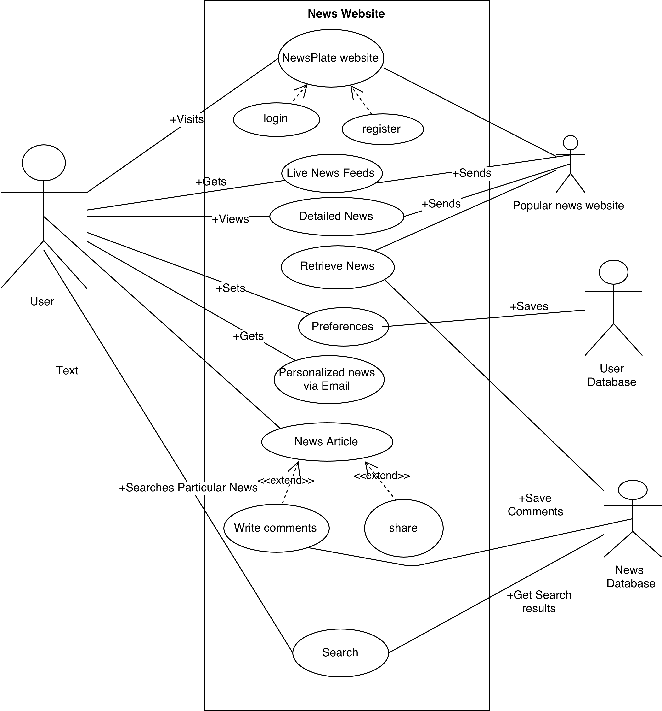**Use case**
  2. **Activity Diagram**

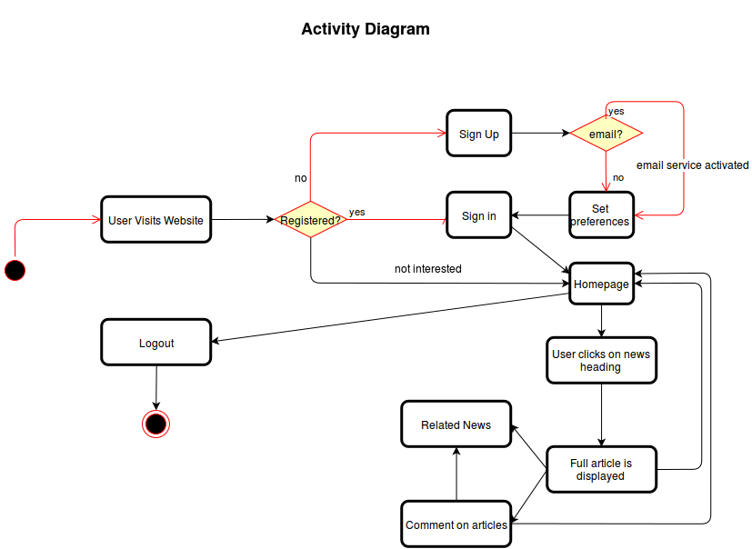

* 1. **Class Diagram**



* 1. **Sequence Diagram**

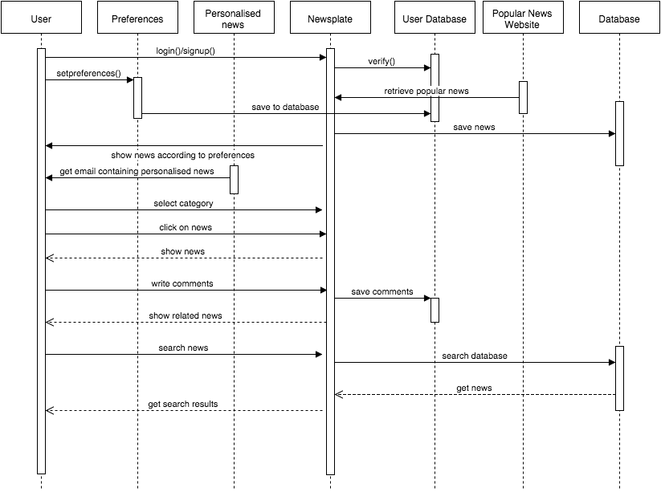

**ScreenShots:**

* Index Page (Carousel)-Recent 10 news from all category will be displayed here which automatically changes.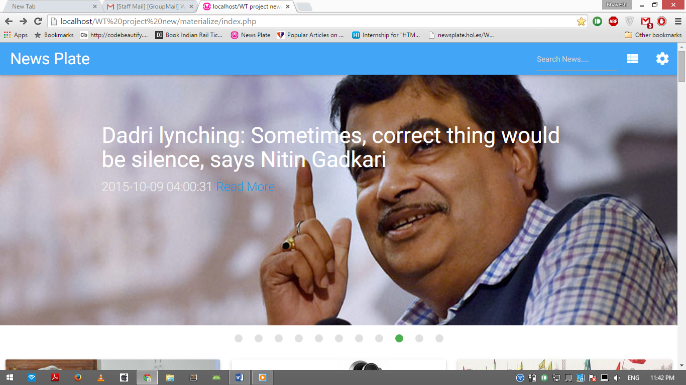
* Index Page-Recent News will be displayed here. At the end there is more news option, so user can read past news as well.

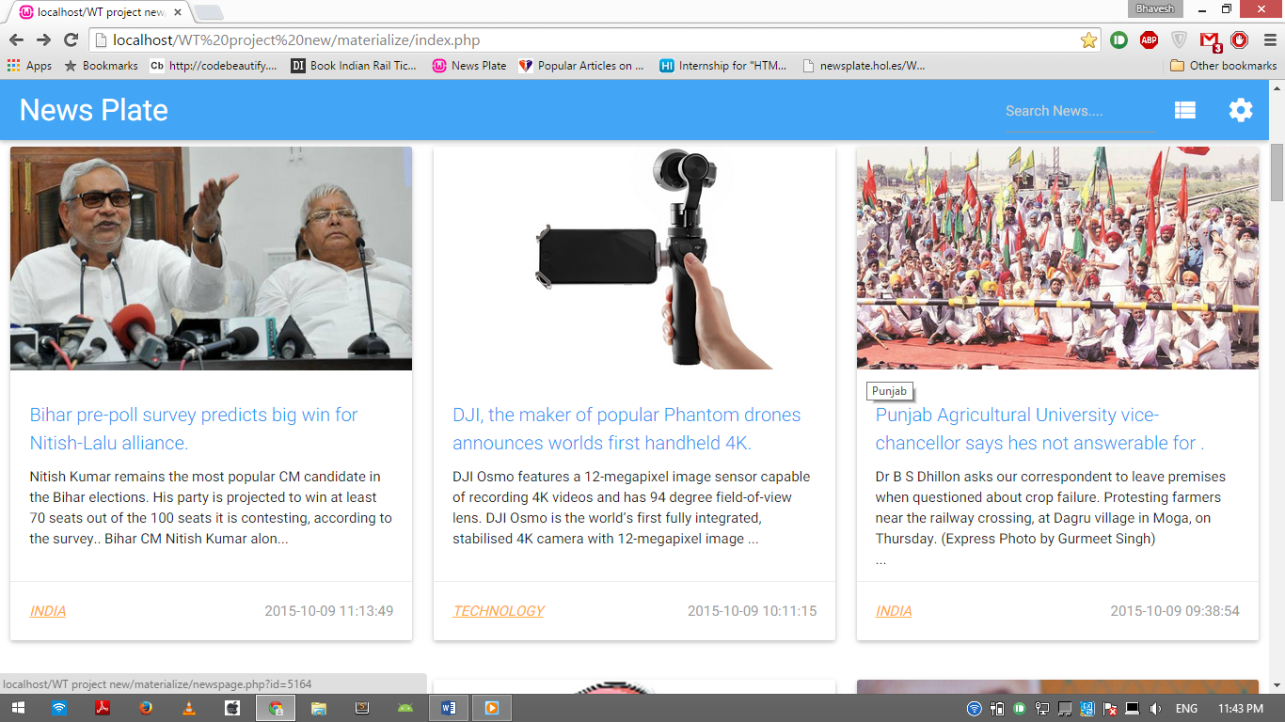

* By clicking on any news, complete description (news) will be shown along with the image if available. (Also shown the category list from the header, user can click on any category to view that category news).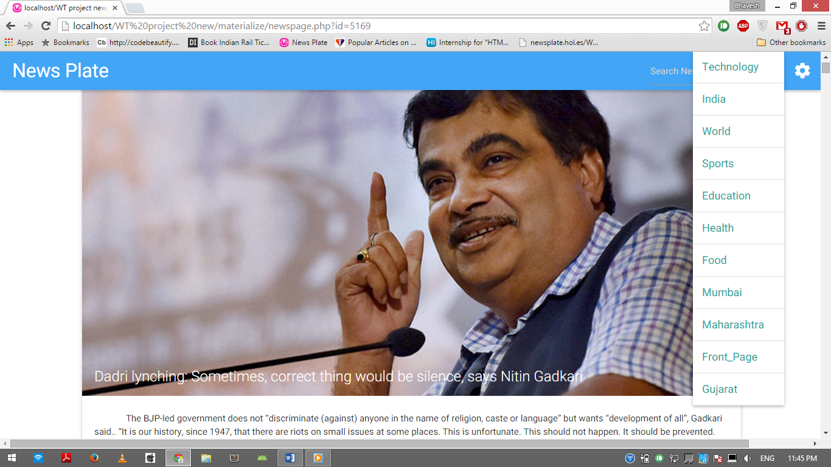
* All the comments to the news will be list below the news, User can also comment on the news only if he/she is logged in.

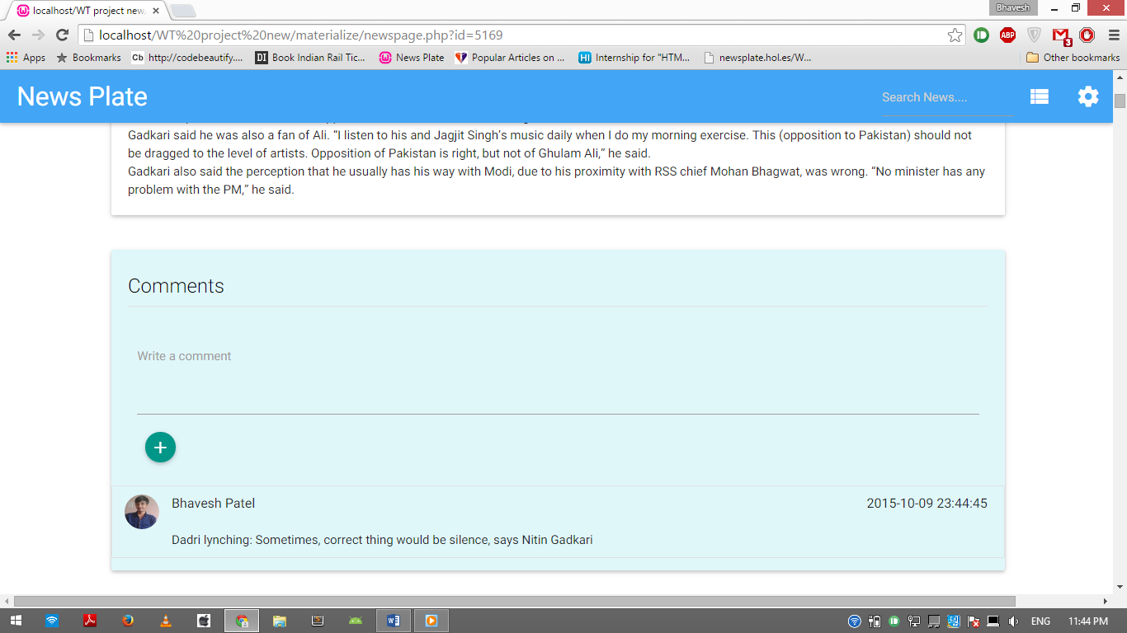

* Related Category news will be listed below the particular news.

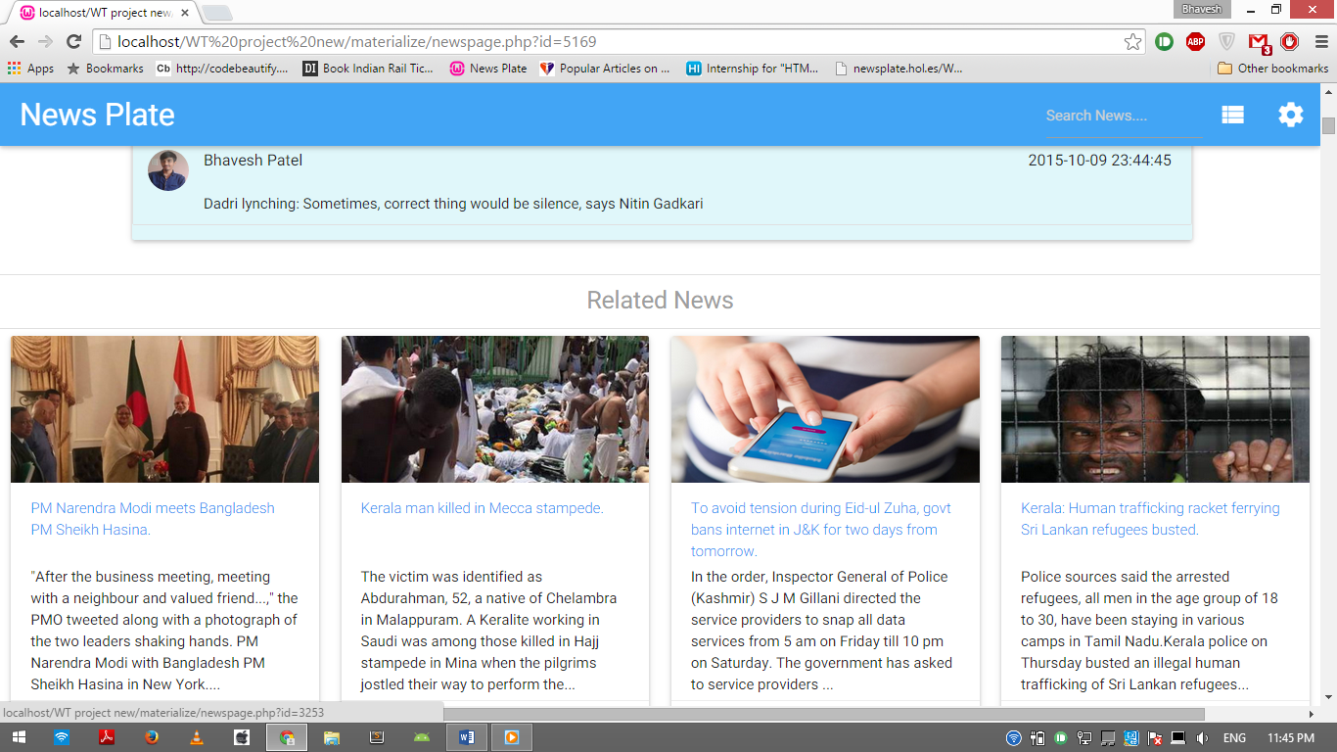

* Category wise news is displayed here.

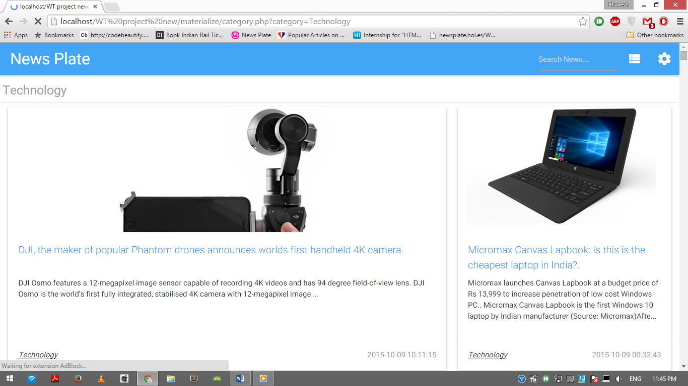

* User can sign up, to get latest news update directly to their Inbox.

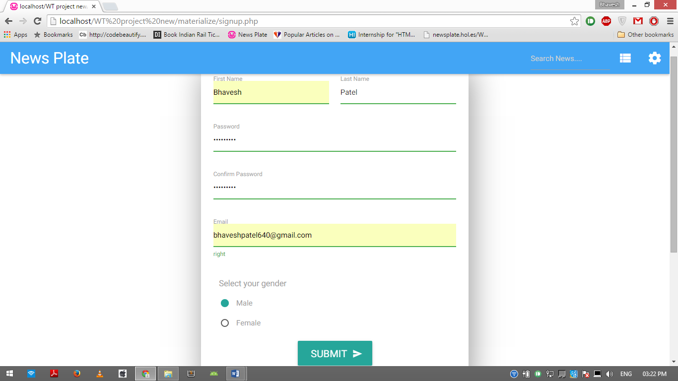

* On signing up user will receive welcome mail

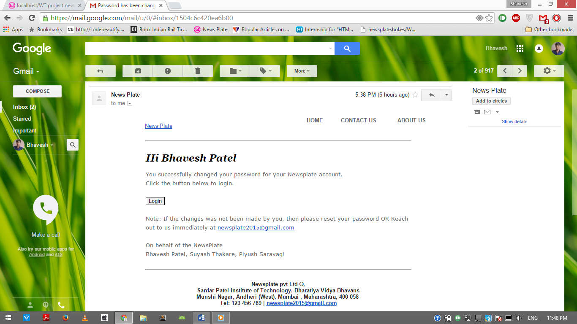

* User can login to set their preferences (also Forgot Password option is there if user forgot their password then auto generated password will be mail to users Email id).

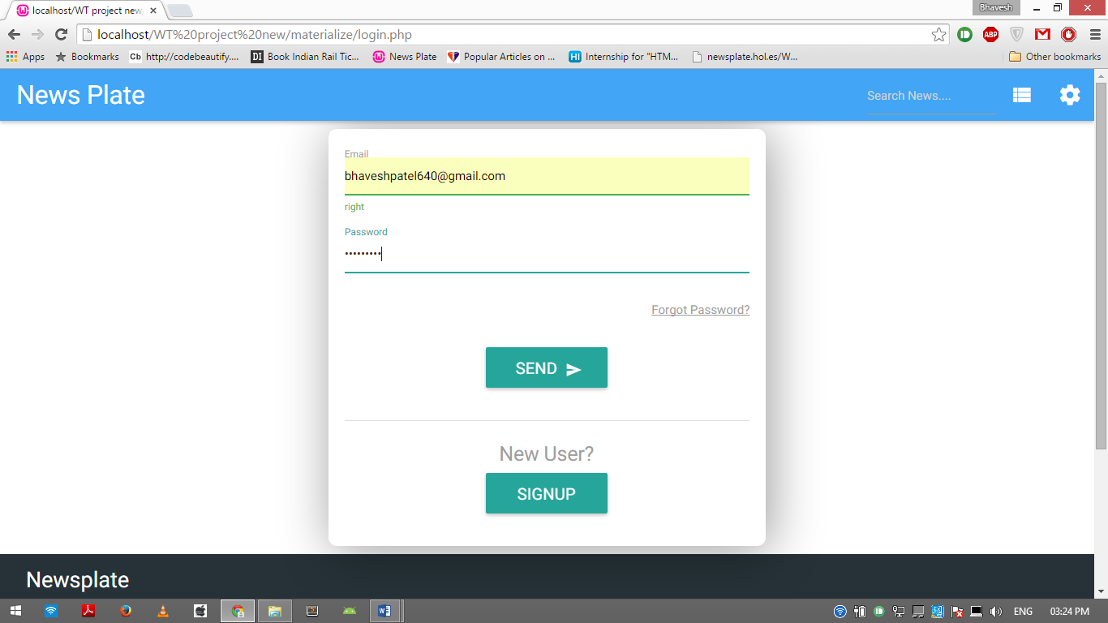

* If user forgot the password then he/she can enter their emailed, new password will be generated and will be mailed.

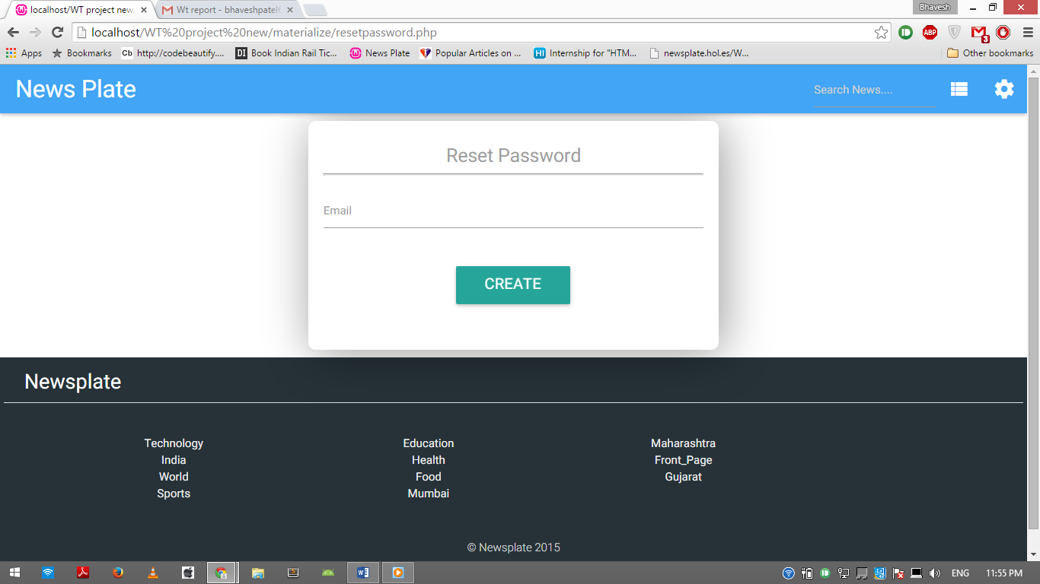

* Auto Generated password will be receive in their inbox.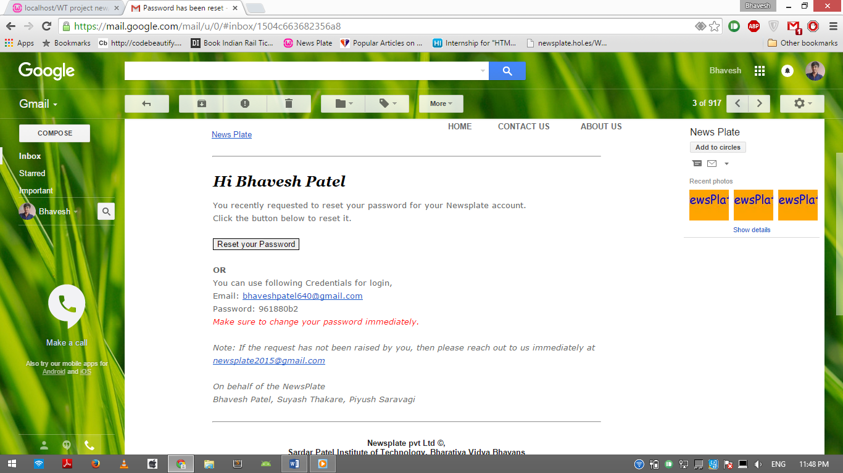
* User can change their password

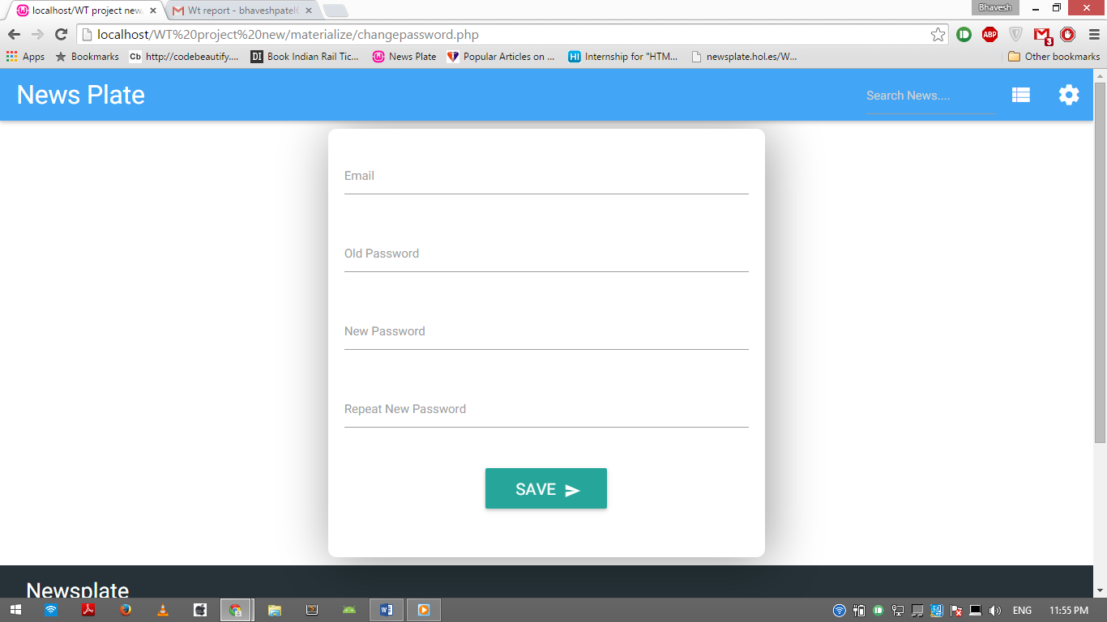

* Changed password notification will be sent to the user



* User can view their profile and can change it. (They can change their First name, Last name, Password, Preferences, Email notification).

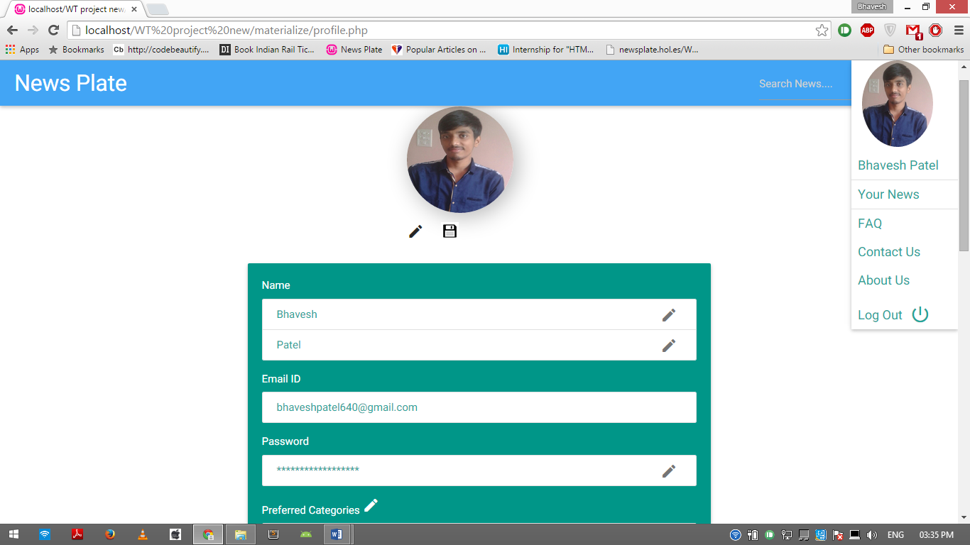

* User can view news according to their preferences

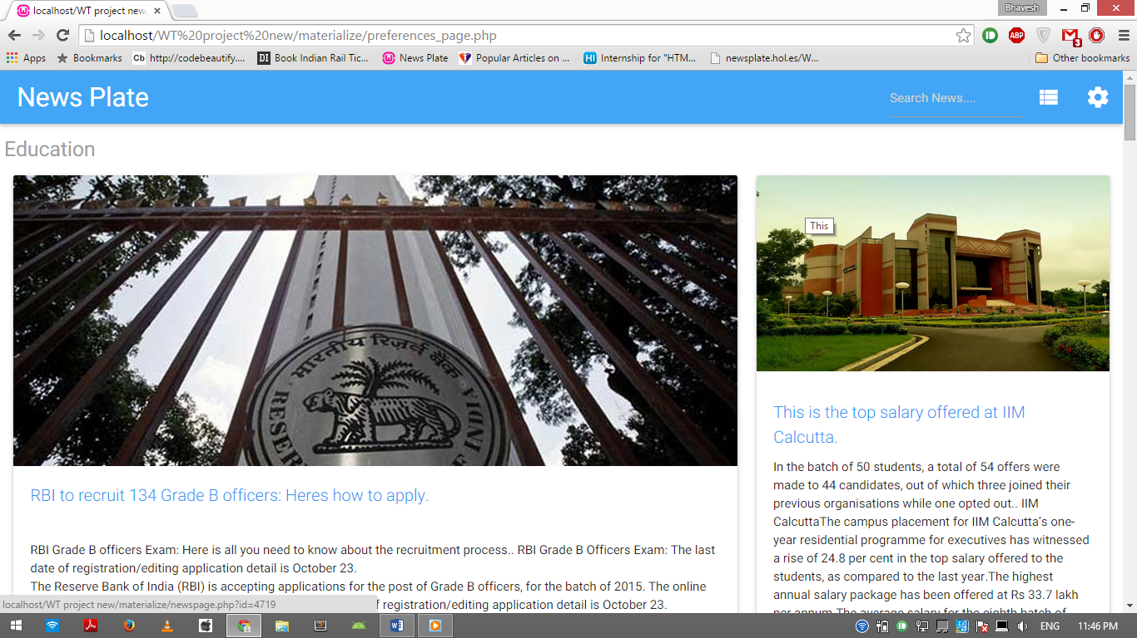

* User can search their news using any keywords

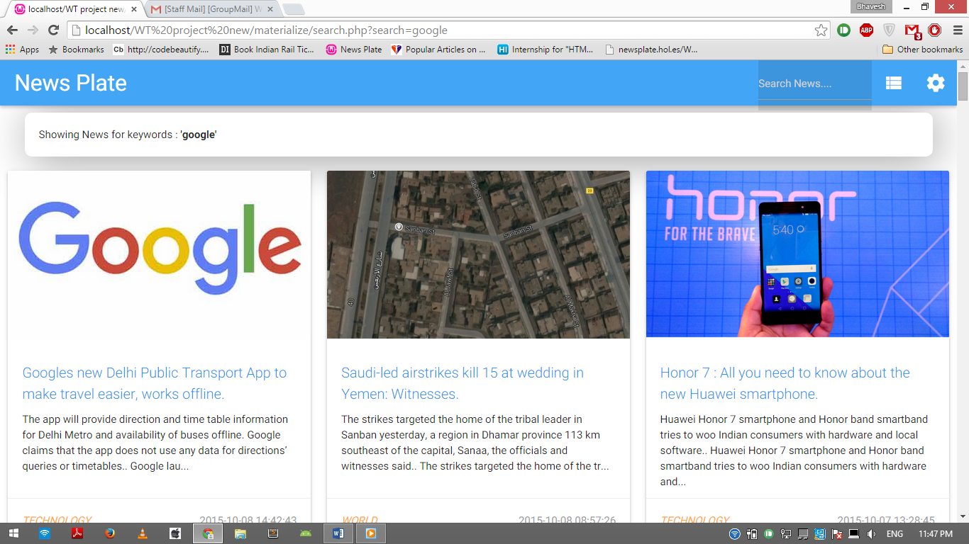

* If the keyword is not found in any news and the footer is also shown.

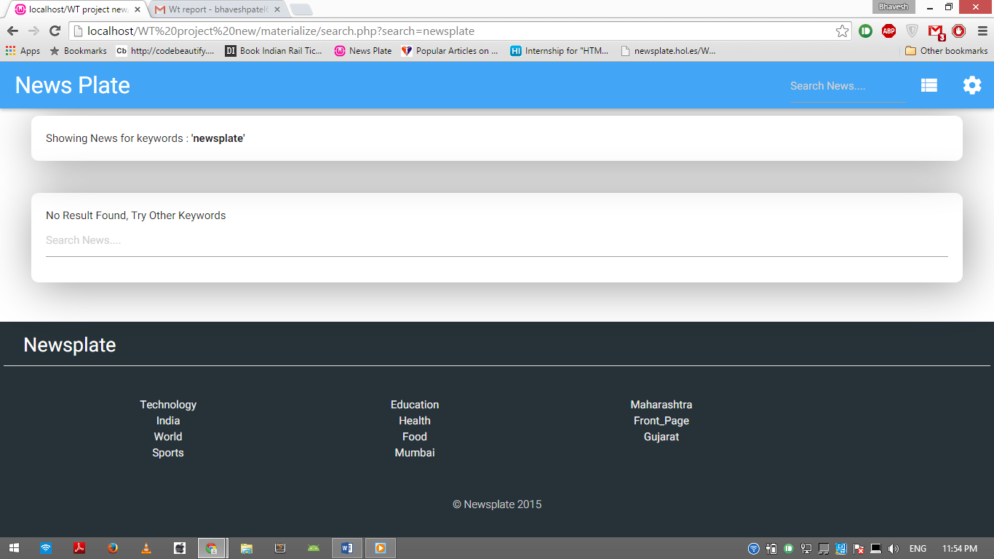

* User can receive latest news according to their preferences in their inbox

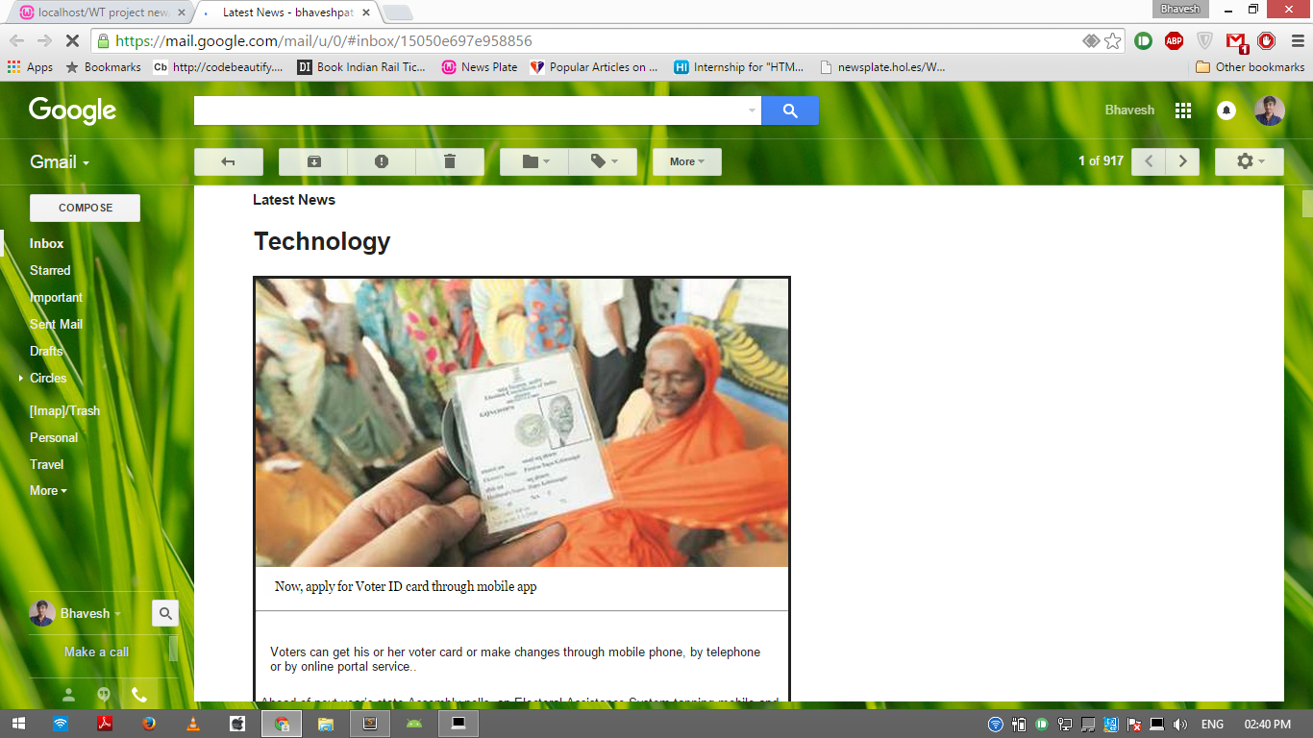

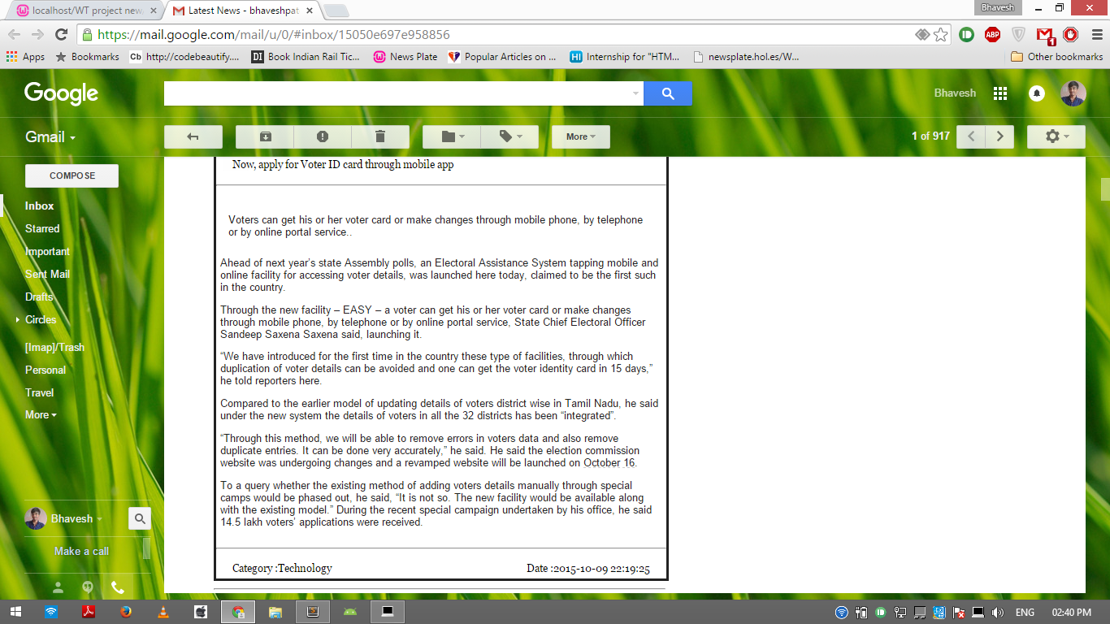

* User can contact us by mailing at “newsplate2015@gmail.com”.

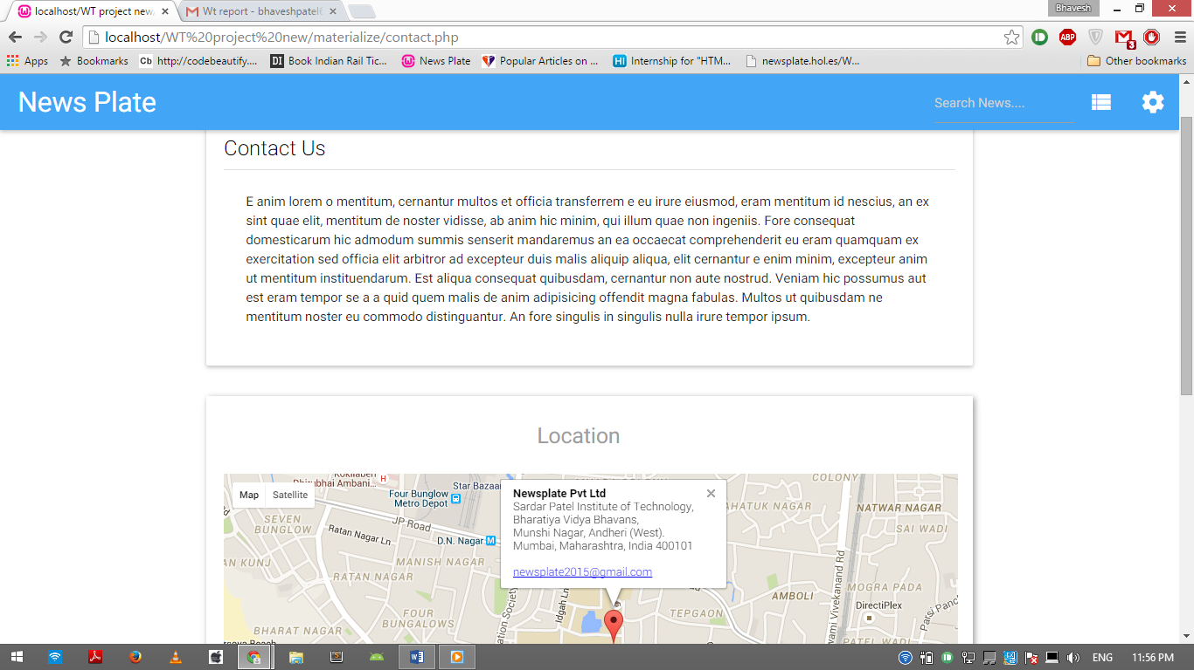

* There is an Admin page in which admin can add new category and its RSS link, after add it will be reflected in all places i.e. header, footer, Users preference settings, etc. Also admin will update the news by clicking on the category buttons. Admin can send latest news mail to all user to clicking send latest news button.

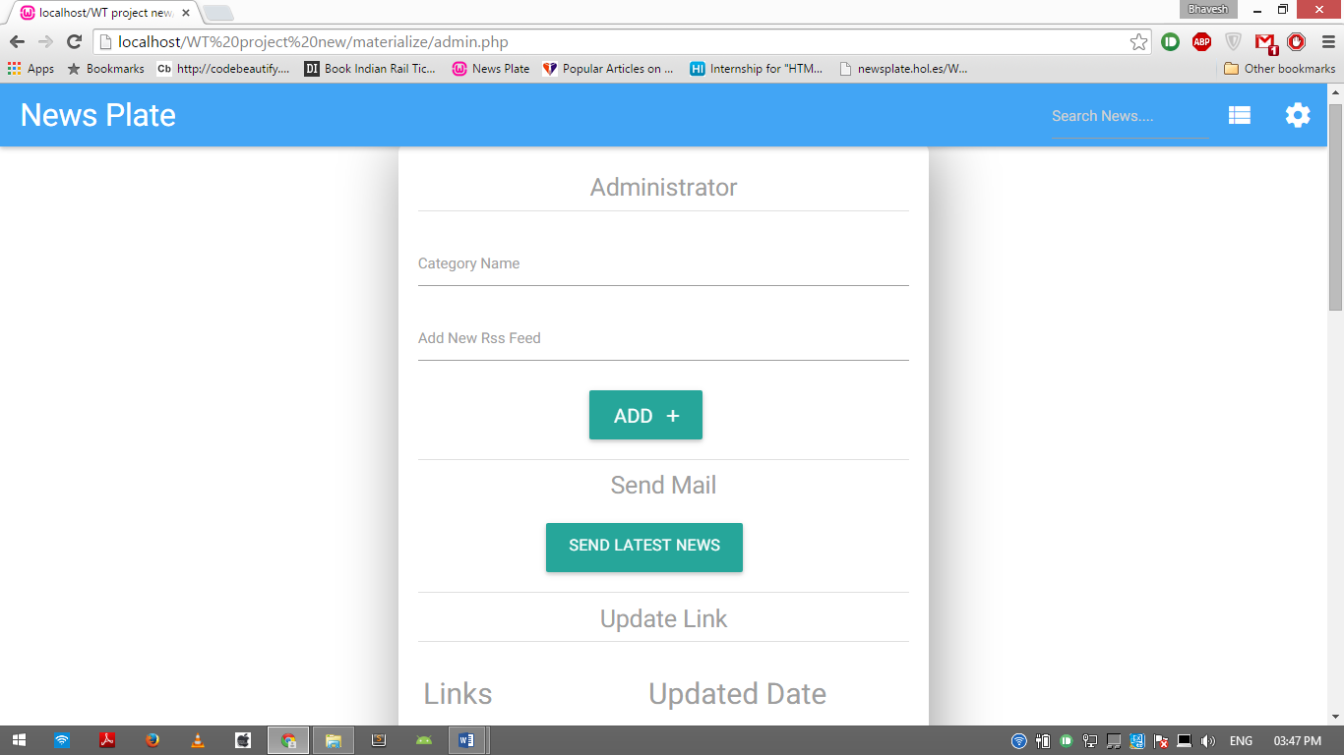

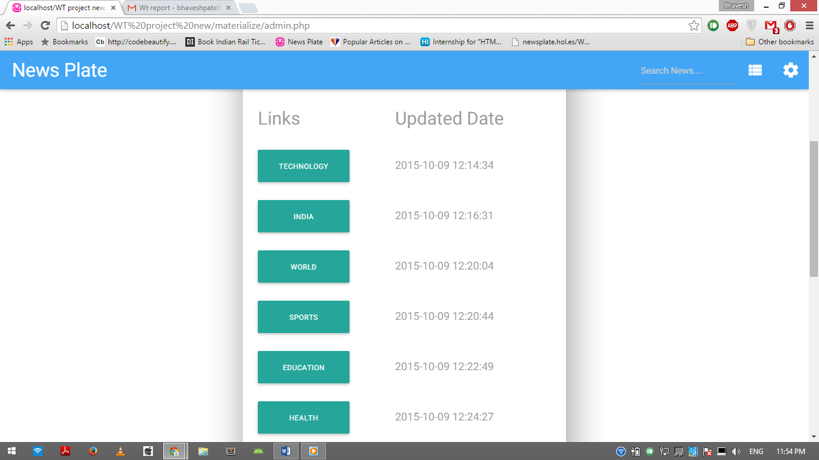

**Source Code of Index Page:**

<?php

include "template/header.php";

$align = array("center", "left","right");

$str=$_SERVER['SERVER_NAME'].$_SERVER['PHP_SELF'];

$str=str_replace("index.php","",$str);

$_SESSION['path']=$str;

?>

<main>

<div class="row">

<div class="slider">

<ul class="slides">

<?php

if(empty($_GET)===false){

if (isset($_GET['num'])) {

$num=$_GET['num'];

}else{

$num=30;

}

}else{

$num=30;

}

$result=$db->query("SELECT * FROM news ORDER BY pubDate DESC");

$x=0;

if($result)

{

while ( $row=$result->fetch_assoc()) {

$i=rand(0,2);

echo '<li>

<img src='.$row['imageSrc'].' title='.$row['title'].' style="opacity:1.0;">

<div class="caption ' . $align[$i] . '-align">

<h3>' .$row['title']. '</h3>

<h5 class="light grey-text text-lighten-3">' .$row['pubDate'].' '. '<a href=' . 'newspage.php?id='.getnewsid($db,$row['link']).'>Read More</a></h5>

</div>

</li>';

if($x==10){

break;

}

$x++;

}

}

?>

</ul>

</div>

</div>

<?php

$result=$db->query("SELECT * FROM news ORDER BY pubDate DESC");

$x=0;

if($result)

{

while ( $row=$result->fetch_assoc()) {

if ($x % 3 == 0) {

echo '<div class="row">';

}

echo '<a href=newspage.php?id='.getnewsid($db,$row['link']).'><div class="col m4">

<div class="card medium" style="height:525px;" id='.getnewsid($db,$row['link']).'>

<div class="card-image">

<img src=' . $row['imageSrc'] . ' title='.$row['title'].' style="opacity:1.0;">

</div>

<div class="card-title" style="height:50px;color:#2196f3;margin-left:20px;margin-right:20px;font-size:20px">

<p>' . substr($row['title'],0,75). '.</p>

</div></a>

<div class="card-content">

<p>' .create_description($row['description']). '</p>

</div>

<div class="card-action">

<span><u><i><a href="category.php?category='.$row['category'].'">' .$row['category'].'</a></i></u></span>

<span class="grey-text"style="float:right;">' .$row['pubDate']. '</span>

</div>

</div>

</div>';

if ($x % 3 == 2) {

echo '</div>';

}

$x++;

if($x==$num){

$num=$num+30;

echo '<div class="row"><div class="row" style="margin:10px"><a href="index.php?num='.$num.'#'.getnewsid($db,$row['link']).'"><h5 class="grey-text">Read More</h5></a></div>';

break;

}

}

}

?>

</main>

<?php include "template/footer.php"; ?>

**Testing**

Web testing is the name given to software testing that focuses on web applications. Complete testing of a web-based system before going live can help address issues before the system is revealed to the public. Issues such as the security of the web application, the basic functionality of the site, its accessibility to handicapped users and fully able users, as well as readiness for expected traffic and number of users and the ability to survive a massive spike in user traffic, both of which are related to load testing.

**Unit Testing:**

Unit testing is a software development process in which the smallest testable parts of an application, called units, are individually and independently scrutinized for proper operation. Unit testing is often automated but it can also be done manually. This testing mode is a component of Extreme Programming (XP), a pragmatic method of software development that takes a meticulous approach to building a product by means of continual testing and revision.

|  |  |  |  |  |
| --- | --- | --- | --- | --- |
| Sr. No | Test Plan | Test cases | Expected Result | Actual Result |
| 1. | Index Page | Most recent news displays first. | Ten recent news should be displayed in the carousel and 30 recent news should be displayed in the index page with more news option. | Ten recent news was displayed in the carousel and 30 recent news was displayed in the index page along with the more news option. |
| 2. | Particular News | Displays Particular news. | User should be able to see particular news with its title, date, content and its category. Below it related news should be listed and comment box with all the comments listed | User was able to see particular news with its title, date, content and its category. Below it related news should be listed and comment box with all the comments listed |
| 3. | Comments | Comment on the news | User should be able to comment to a particular news | User was able to comment to a particular news only if he is logged in and if user click add button without any comment that will also be added to it. |
| 4. | Login | Check email and Password. | If the user is already the registered then he/she is prompted to login. If the email and password matches with those in database then there are no errors displayed otherwise error ‘Email Id Or password Incorrect’ error is displayed. | If the user was already registered then he/she was prompted to login. When the email and password matched with those in database then there were no errors displayed otherwise error ‘Email Id Or password Incorrect’ error was displayed. |
| 5. | Register | Register and validate the Inputs | The user fills the registration form. Inputs like the email id, name, and gender are validated. If there is some problem then error is popped up regarding input is required. | The user filled the registration form. Inputs like the email id, name were validated. When there was some problem then error was popped up regarding input was required. Expect verification of email whether it is exist in real time or not. |
| 6. | Password Lookup | User forgot password or want to changed password. | If the customer clicks forgot password, then a new password is mailed to the registered email if the email id matches with those in database, otherwise a message is prompted that the email id does not found in database. User can also change the password and notification of changing password should be sent to the users email id. | When the customer clicked forgot password, then a new password was mailed to the registered email when the email id matches with those in database, otherwise a message was prompted that the email id does not found in database. (If there is any issue with the mail sending not popped is displayed). User was also change the password and notification of changing password was receive to the users email id. |
| 7. | News Preferences | News according to preferences | This page cannot be access unless user logged in. If no preferences are set then ‘Please set your preferences’ should be displayed. | This page cannot be access unless user logged in. If no preferences are set then ‘Please set your preferences’ was be displayed and link to set preferences page was there. |
| 8. | Profile photo | Set profile photo | User can set profile photo in its profile page. | User was able to set photo and save it to database, but the image was not perfectly in circle it was oval in shape. |
| 9. | Search News | Search news | User should be able to search news by passing keywords. | User was able to search, but keyword can be anything i.e. it can be spaces any other word which should not be the keyword. |
| 10 | Logout | User can logged out | User should be able to logout successfully. | User was able to logout successfully, but no popup as he/she was logout successfully |
| 11. | Admin Login | Admin can login | Admin should login with specific credentials. | Admin was successfully logged in with the specific credentials. |
| 12. | Add Category | News Category can be added | Admin can add the new category with its name and its RSS link from the referred website. | Admin can add new category but there was no verification of the link. |
| 13. | Update News | Admin can Update news | On clicking the update button of specific news, news should be update in the database. | On clicking the update button of specific news, news was updated and updated date was displayed and dynamically news was displayed in index page. |
| 14. | Send Latest News to the user. | Latest news to all register user | Admin can send latest news of all category to the registered user. | Admin was able to send latest news of all category to the registered user. But was send to all registered users even if he/she is not checked news update subscription. |
| 15. | RSS Feed | Update news using RSS feeds | Admin can click update button to update news, news should be saved in the database | User from the referred news website was dynamically save into database and all the images links was saved into database with its attributes like title, content, date and category. |
| 16. | Mail Latest News | Latest news mail to user | Mail should be receive to the user email id | Mail was receive and user was able to read the news, but not display as expected. |

**Integration Testing:**

**Integration testing** is the phase in software testing in which individual software modules are combined and tested as a group. It occurs after unit testing and before validation testing. Integration testing takes as its input modules that have been unit tested, groups them in larger aggregates, applies tests defined in an integration test plan to those aggregates, and delivers as its output the integrated system ready for system testing.

|  |  |  |  |  |  |
| --- | --- | --- | --- | --- | --- |
| Sr. No | Test Plan | Test cases | Expected Result | Actual Result |  |
| 1. | Login validation | Validate the credentials | If Invalid credential is present, an error page is shown. Valid information results in successful login and the user is directed to the index page. | If Invalid credential was present, an error page was shown. Valid information results in successful login and the user was directed to the index page. |
| 2. | Register | News User Register | If the name consist of any number or any special character, popup should be shown. Email id validation and verification should be there. | If the name consist of any number or any special character, popup was should be shown and same was save in database. Email id validation was there but verification whether exist in real time was not there. |
| 3. | Comment on the news | Comment With Login and without Login | If the user is Logged In, he/she can comment on the news. If the user is not logged in he is directed to the login page with an alert as ‘you need to login to comment’ | If the user was Logged In, he/she was able comment on the news. If the user is not logged in he was directed to the login page with an alert as ‘you need to login to comment’. If blank comment was add then it was also save in the database. |
| 4. | To check the working of Login Logout box on Header bar | All pages of the website | The Login should change to Logout on successful Login and its preference news option and profile option with profile photo should be there. | The Login was change to Logout on successful Login and its preference news option and profile option with profile photo was be there, and user if logged in cannot visit signup page and forgot password page. It was worked in all pages. |
| 5. | Preferences News | News according to the user | If user logged in he/she can access preferences page and view preferred news according to category. Otherwise user should direct to other page | If user logged in he/she was able to access preferences page and view preferred news according to category, but all the news from that category was listed that with very long page generated. Otherwise user should direct to index page. |
| 6. | Update news | Update news from referred new website | Admin should able to update news. | As soon as update button was clicked news were stored in database. It is dynamically loaded on the index page. But admin manually want to update every category news and option to update all category news automatically. |
| 7 | Mail News | Admin can mail latest news | Admin can mail news to every user who has subscribe update alert. | Admin can mail news to every user who was and not subscribe update alert. It takes very long time to send the news and was also manually button clicking function. Automatically to a specific time sending was not there. |

**LINK TESTING**

Linking test is to test a group of unit to ensure that the unit operate correctly in combination. It is normally performed after the individual unit have been tested in isolation and prior to the integration testing that is performed for the complete system.

|  |  |  |  |  |
| --- | --- | --- | --- | --- |
| Sr. No | Test Plan | Test cases | Expected Result | Actual Result |
| 1. | New user Register | Click on signup button on login page | If Invalid data is present, an error is shown. Valid information will link to profile page | If Invalid data was present, an error was shown .Valid information will link to profile page |
| 2. | Login | Clicking on login/register button in navigation bar | If valid credentials is supplied it is link to index page else is link to error page with specific error and the directing link. | If valid credentials was supplied it was link to index page else was link to error page with specific error and the further directing link. Specific pages which only registered user can access was accessed by the user else it was redirected to the index page. |
| 3. | Particular news | User visits particular news | On clicking any news user is visited to the news page and on comment same page should be refreshed with new comment listed | On clicking any news user was visited to the news page and on comment same page was refreshed with new comment listed below the news. |
| 4. | Admin login | Admin can visit admin page | Other user other than admin can visit admin page it is redirected to the index page or any other page | Other user other than admin can visit admin page it is redirected to the index page or any other page |
| 5. | Forgot Password | Click on the forgot password link in the Login page | The user is directed to the Forgot Password page consisting of a form. After passing email id and on clicking the Submit button, the new password is sent to the user through an email. | The user was directed to the Forgot Password page consisting of a form. After passing email id and on clicking the Submit button, the new password was sent to the user through an email. |

**System Testing:**

System testing of software or hardware is testing conducted on a complete, integrated system to evaluate the system's compliance with its specified requirements. System testing falls within the scope of black box testing, and as such, should require no knowledge of the inner design of the code or logic.

As a rule, system testing takes, as its input, all of the "integrated" software components that have passed integration testing and also the software system itself integrated with any applicable hardware system(s).

|  |  |  |  |  |
| --- | --- | --- | --- | --- |
| Sr. No | Test Plan | Test cases | Expected Result | Actual Result |
| 1. | Login | Login with valid credentials. | All pages will reflect the logged in user with the option ’Logout’ in the navigation bar | All pages reflected the logged in user with the option ’Logout’ in the navigation bar |
| 2. | Registration | Register the new user and update database. | User should be able to view their preference news | User was able to view their preference news |
| 3. | Save the comment | 1. Save the comment entered by the user.  2.Proper retrieval from database | When the new comment is added, it should be retrieved properly from database so as to reflect the latest comment on the news page. | When the new comment was added, it was retrieved properly from database and reflected on the news page. |
| 4. | Mail to the user | Mail the user according to the cases | User should receive the mail for the cases like new user registered, forgot password, changed password, News updates. | User was able to receive the mail for the cases like new user registered, forgot password, changed password, News updates only if there won’t be any mailing issue from the server. |
| 5. | Updating of news. | Deals with the addition of latest news in the database. | Admin should be able to update the news and store it in database, he can also add the new category in it. | Admin should be able to update the news unless there won’t be any issue with the other referred news website. New category was been added if the supplied RSS link was correct else error is displayed |

**Browser Testing:**

Browser Testing is a process to test web applications across multiple browsers. Browser testing involves checking compatibility of your application across multiple web browsers and ensures that your web application works correctly across different web browsers. Browser testing involves testing both the client side and server side behavior of your Web application when it is accessed using different Web Browsers.

|  |  |  |  |  |
| --- | --- | --- | --- | --- |
| Sr. No | Test Plan | Test cases | Expected Result | Actual Result |
| 1. | Google Chrome | Entire website | Should display and work properly | The website worked properly, if title exceed certain length of charter it is overlapped over the content. White title sometime not visible over the certain image. FAQ page was not functioning properly. |
| 2. | Mozilla Firefox | Entire website | Should display and work properly | The website not worked properly as expected, if title exceed certain length of charter it is overlapped over the content. White title sometime not visible over the certain image. It take long time to load and password filled was not been styled as expected. FAQ page was not functioning properly. |
| 3. | Opera | Entire website | Should display and work properly | Worked same as Mozilla Firefox |
| 4. | Internet Explorer  (10 and above) | Entire website | Should display and work properly | The website not worked properly as expected  It take long time to load and password filled was not been styled as expected. FAQ page was not functioning properly. |
| 5. | Internet Explorer  (Below 10) | Entire website | Should display and work properly | Several features working hampered. It take long time to load all the images.  On searching news footer was not displayed properly. |